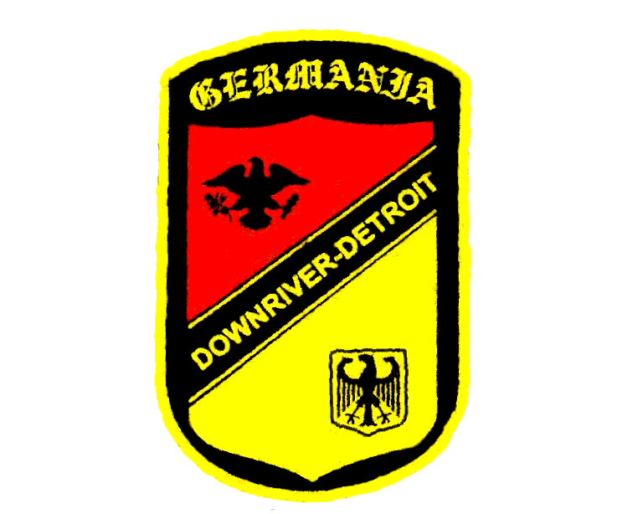
2015 - Wednesday Night Dinner menu - Germania Club Downriver

Germania Club invites the public to be our guest at our
Home Cooked WEDNESDAY NIGHT DINNERS
Dinner is served from 5:00pm to 7:00pm.
The cost is $10 unless otherwise specified .
A cash-bar of fine German beers, wines & liqueurs are also available.
Please join us for dinner!!!

Was gibt’s zum essen? (What’s for dinner?)

January 21
Rouladen -or- schnitzel
February 18
Gulasch + Semmelknödel -or- schnitzel
March 18
Fish & chips + coleslaw –or- schnitzel
April 15
Half Cornish Hen –or-schnitzel
May 20
Aschenbraten (roast pork) –or- schnitzel
June 17
German Picnic (sausages & such)
July & August = NO DINNERS!
September 16
Stuffed Cabbage –or- schnitzel
October 21
Wild Game Dinner (German style) –or- schnitzel
November 18
Bamberger Zwiebel (meat stuffed onions) –or- schnitzel
December 16
*Roast Duck + Potato Dumplings –or- schnitzel
**Call to reserve your Duck selection for December’s dinner
by Sunday December 13th!**

All Dinners Include: sides, salad, bread, coffee and tea
along with a light dessert baked by our own members
Cash Bar
Carry-Outs Available

